DAY 2_AWS Elastic Compute Cloud

DAY 2_EC2_CE1

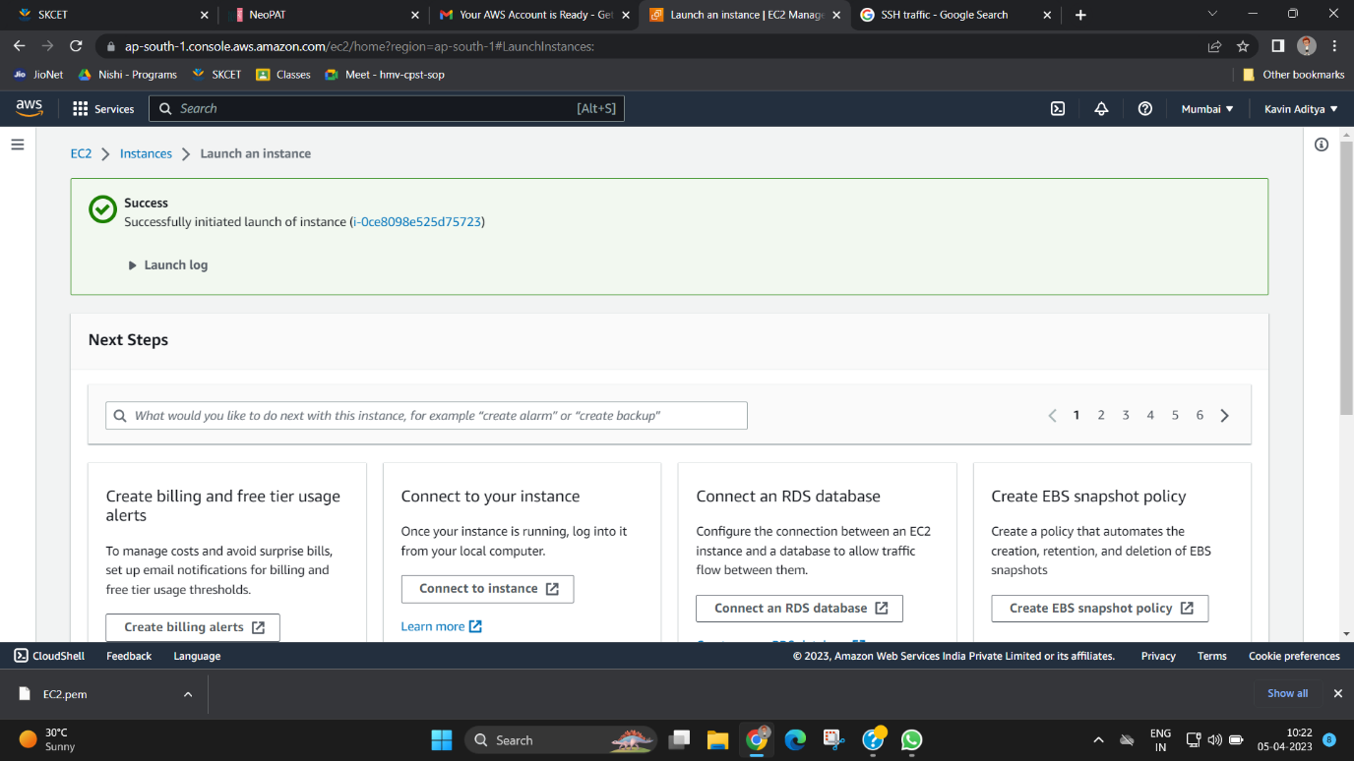

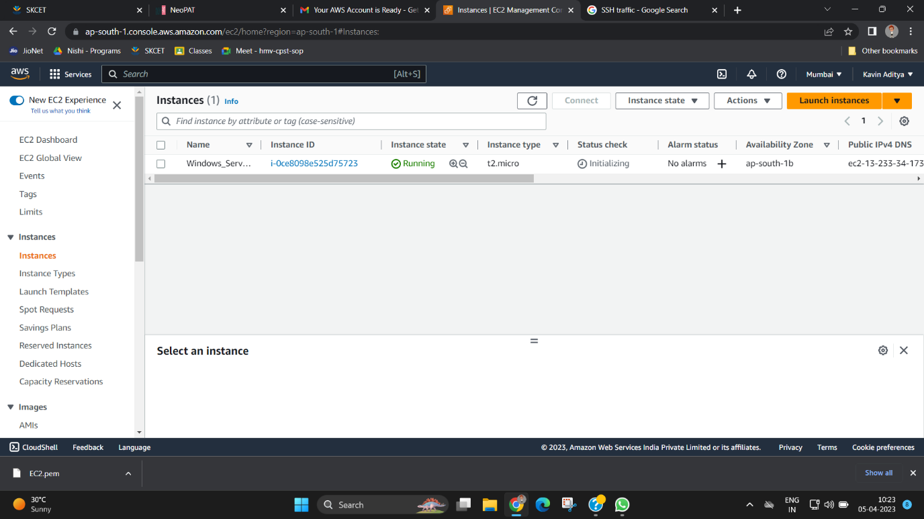

DAY 2_EC2_CE2

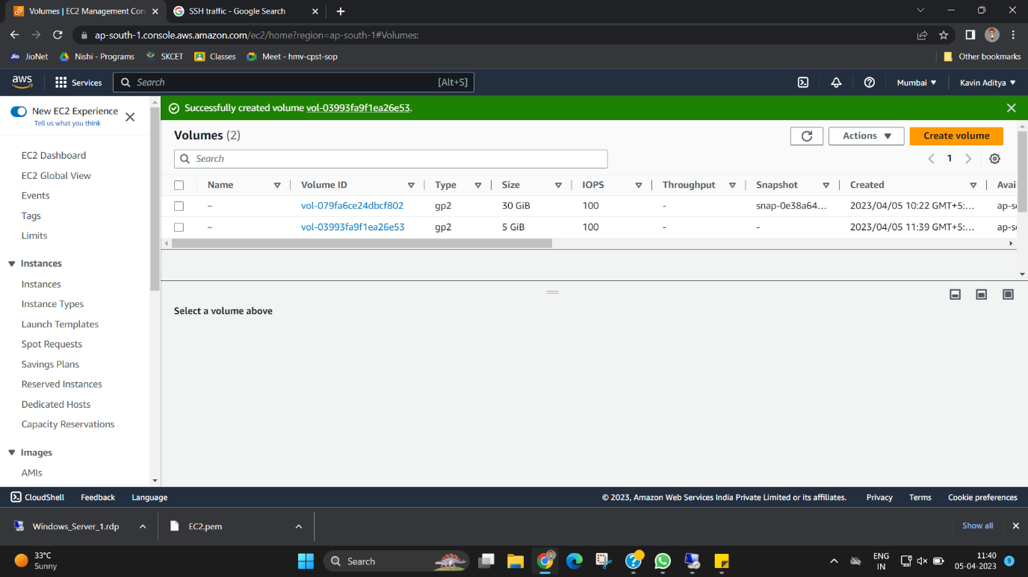

DAY 2_EC2_CE3

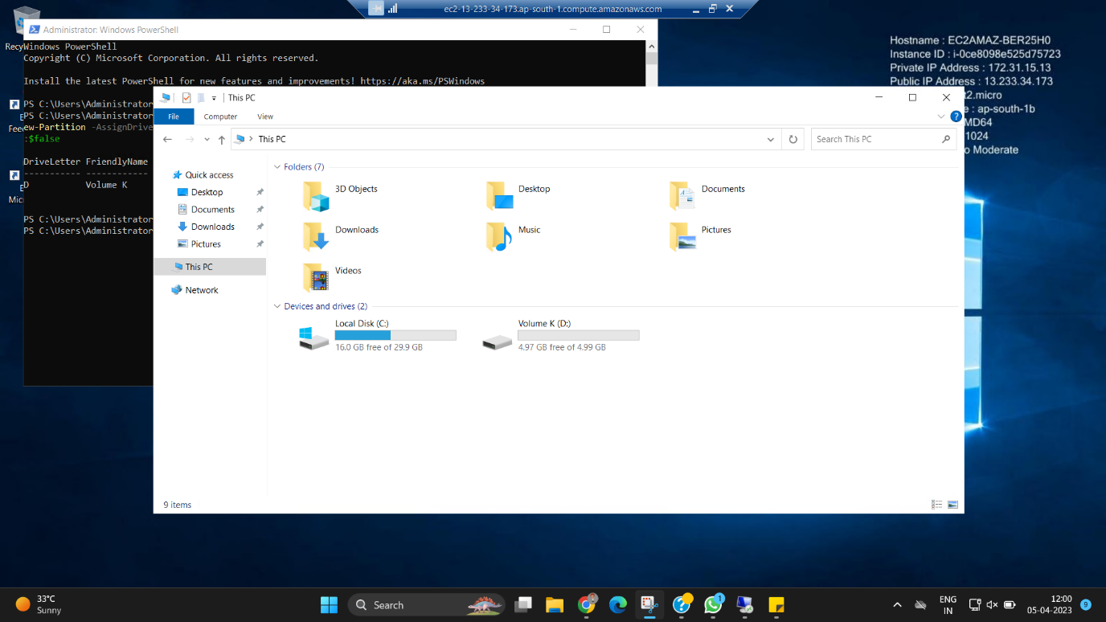

DAY 2_EC2_CE4

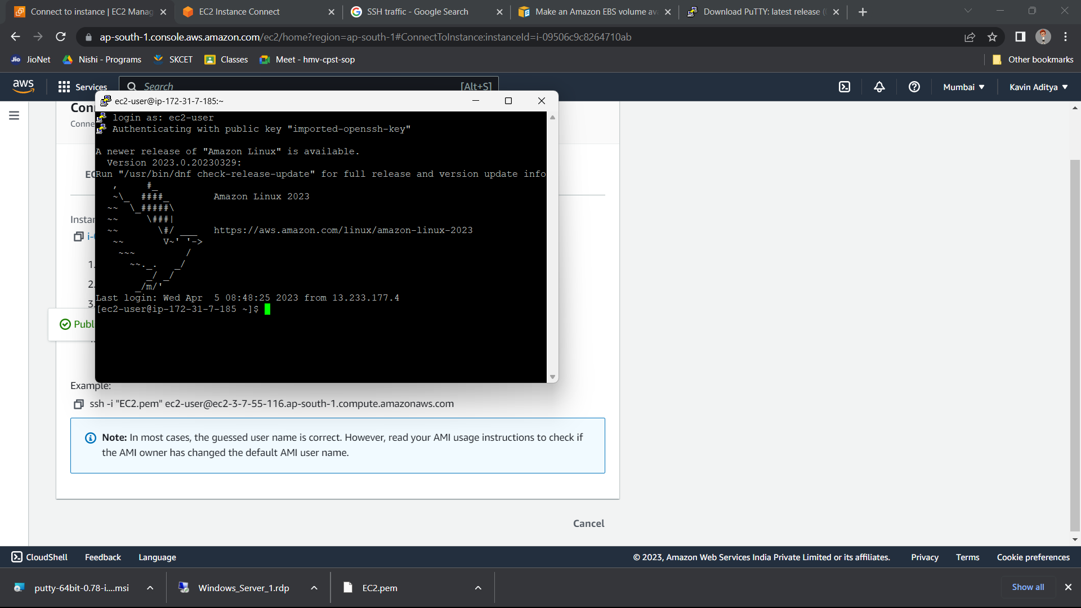

DAY 2_EC2_CE5

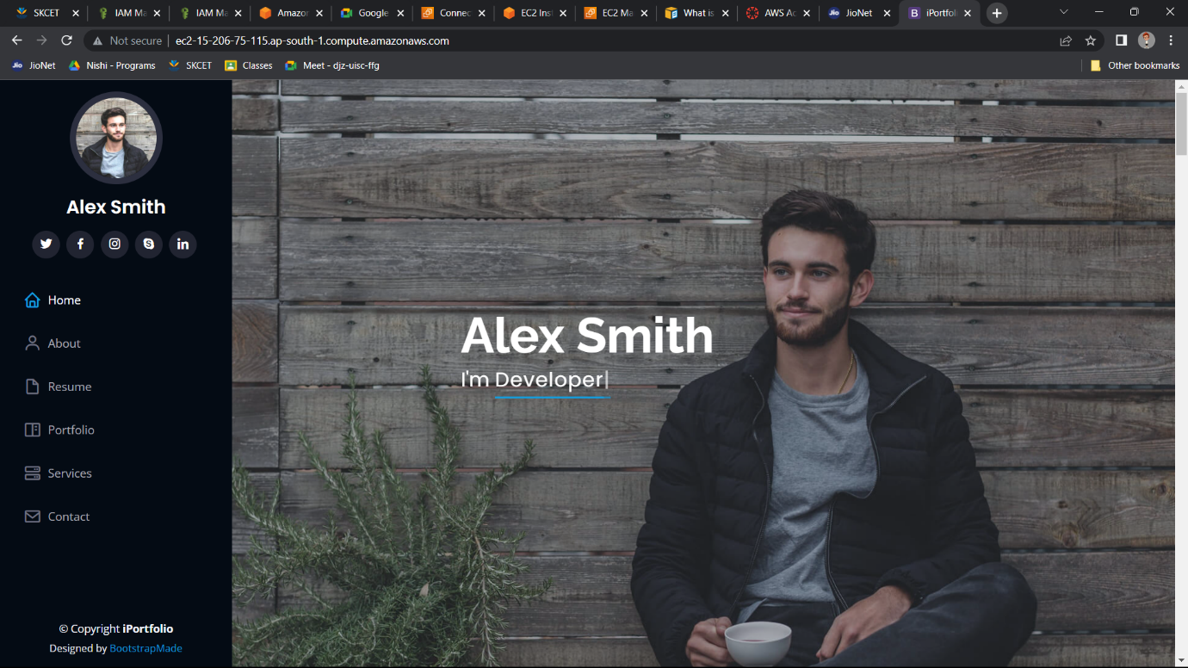

Day 2_EC2_CE6

